

WORLD BANK SUSTAINABLE CITIES PROJECT RENEWABLE ENERGY PROJECTS

ÇEKEREK MUNICIPALITY SOLAR POWER PLANT PROJECT (1200 kWe)
ENVIRONMENTAL AND SOCIAL MANAGEMENT PLAN


JULY 2024
DOCUMENT CONTROL PAGE
File Name: | ESMP(EN)_GES_Cekerek_15122023_v3
Prepared by | Doğukan ARIKAN
Date | 17 July 2024
Version | Version 03
Document status: | Final
Use of the document: | World Bank, Ilbank

Name & Surname | Responsibility
Doğukan Arıkan | Environmental Engineer
Aslugül Uğur | Environmental Engineer
M. Öner Akten | Environmental & Social Expert

TABLE OF CONTENTS
LIST OF FIGURES IV
LIST OF TABLES V
TABLE OF ANNEXES VI
ABBREVATIONS VII
EXECUTIVE SUMMARY 8
1. PROJECT DESCRIPTION 10
2. ENVIRONMENTAL AND SOCIAL SCREENING 13
3. LEGAL AND INSTUTIONAL FRAMEWORK 17
3.1. National Legal Framwork 17
3.2. International Legal Framework 17
4. BASELINE 19
4.1. Project Area 19
4.2. Natural and Cultural Resources 20
4.3. Project Land Use Rights 20
4.4. Socioeconomic Situation 22
5. ENVIRONMENTAL AND SOCIAL MANAGEMENT PLAN 25
5.1. Mitigation Plan 26
5.2. Monitoring Plan 35
6. STAKEHOLDER ENGAGEMENT 44
6.1. Stakeholder Analysis 44
6.2. Previous Stakeholder Engagement Activities 44
6.3. Stakeholder Identification and Analysis 44
6.4. Stakeholder Engagement Program 45
6.5. Roles and Responsibilities 46
6.6. Grievance Mechanism 47
6.7. Monitoring and Reporting 49
7. CONCLUSION 50

LIST OF FIGURES
Figure 1. Project Area 11
Figure 2 Location of Yozgat Province and Çekerek District 19
Figure 3. Turkey's Solar Energy Potential Atlas 20
Figure 4: SPP Area and Grid Connection 22
Figure 4: Engagement Diagram 45
Figure 5: Grievance Mechanism Flow Chart 48

LIST OF TABLES
Table 1. Project Area Corner Points Coordinates (ED50) 21
Table 2. Fifth Tier Developed Provinces 23
Table 3. SEDI Indices of Yozgat Districts 24
Table 4. Mitigation Plan of the Project 26
Table 5. Monitoring Plan of the Project 35
Table 6. List of Stakeholders 44
Table 7. Responsibilities of Key Actors/Stakeholders in SEP Implementation 46

TABLE OF ANNEXES
Annex 1 | Deed of the Area and Urban Planning
Annex 2 | EIA Not Required Certificate
Annex 3 | Environmental and Social Screening Form
Annex 4 | Minutes Of Stakeholder Consultation Meeting

ABBREVATIONS
EDAŞ | Electricity Distribution Joint Stock Company
EIA | Environmental Impact Assessment
ESMP | Environmental and Social Management Plan
ES | Environmental and Social
ESS | Environmental and Social Screening
EU | European Union
kWh | Kilowatt-hour
MoLSS | Ministry of Labor and Social Security
MoEUCC | Ministry of Environment, Urbanization and Climate Change
PV | Photovoltaic
SPP | Solar Power Plant
SCP | Sustainable Cities Project
SCP-II | Sustainable Cities Project -II
SCP-II -AF | Sustainable Cities Project -II Additional Financing
SPP | Solar Power Plant
TEİAŞ | Turkish Electricity Transmission Joint Stoc Company
USD | United States Dolar
WB | World Bank

EXECUTIVE SUMMARY
Çekerek Municipality Solar Power Plant is a sub project of Sustainable Cities Project – II – Additional Financing which will be financed by the World Bank in order to support sustainable development of Turkiye. Since the project will financed by the World Bank, the project shall comply with both local Environmental Legislation and World Bank’s Safeguard Policies.
Çekerek Municipality Solar Power Plant Project has installed capacity of 1200 kWe / 1436.4 kWp and total project area of 2.172 ha. The project will help Çekerek Municipality to generate clean energy and meet some of its energy needs in a environmental way. The project will be implemented in Yozgat Province of Çekerek District.
After environmental and social screening the project is classified as Category B Low, so simpflied environmental and social management plan has been envisaged and this report has been prepared accordingly.
Potential environmental and social impacts during the construction and operation have been pointed out and mitigation measures and monitoring requirements have been set with this report. Main findings of the report are briefly mentioned in following sections and in detail in following sections.
The waste generation due to the project causes some risks to the environment and human health and risk of this has been determined as medium before the mitigation. To eliminate this risk, wastes will be collected and separated and stored in a safe storage area and no contamination or spill will be let and related regulations will be followed. After these mitigations, importance of the risk will be low.
Due to transportation activities, exhaust emissions may increase. To mitigate this impact, routine maintenance of the machinery and equipment will be performed and related regulations will be followed. The fuel to be used in the project will be in accordance with the standards. After these mitigation measures, the impact of this parameter will be low.
Workers employed by third parties and supply chain will have its own Environmental and Social Management System (ESMS) to ensure that they operate in a manner consistent with working conditions requirements.
For the risk of temporary worker flows and risk of social conflict Impacts on community dynamics, the work’s contractor will prepare a Workforce Management Plan and minimize the risk.
Inadequate worker health and safety conditions is another risk to be mitigated. The work site and workers will be ready to any emergency situation and any health and safety issue. Working conditions of the workers will be inline with the local legislations.
In case of emergency response, an Emergency Preparedness and Response Plan will be prepared by the contractor and in emergency, this plan will be followed.
To minimize greenhouse gas emissions, all machinery and equipment will be optimally utilized to reduce GHG. Regular maintenance of the equipment will be carried out, and staff will be trained related to energy efficiency.
All stakeholders will be communicated, and they will be informed about the project. A clear grievance mechanism will be prepared, and information will be publicized. All details of victims of Gender Based Violence (GBV) and Sexual Exploitation and Sexual Exploitation and Abuse/Sexual Harassment (SES/ST) will be kept strictly confidential in the Complaint Registration Database.

PROJECT DESCRIPTION
In May 2019, the World Bank’s Board of Executive Directors approved financing of 500 million euros (USD 560.6 million equivalent) to support sustainable development in Turkish cities. A Loan Agreement of 500 million euros for Sustainable Cities Program-II Additional Financing (SCP-II-AF) was signed between the World Bank and ILBANK on July 10th, 2019.
The loan took effect on November 5th, 2019. It aims to meet municipal needs in infrastructure, zero waste, transportation, energy efficiency, renewable energy, municipal social services, disaster recovery, urban renewal, and restoration sectors. SCP-II-AF aims to assist Municipalities and Administrations in financing priority investments for infrastructure service requirements stipulated in the Metropolitan Municipality Law No. 6360 and amended in December 2012. SCP-II-AF aims to improve the planning capacity of and access to targeted municipal services in participating municipalities and utilities.
In this context, Çekerek Municipality has planned to implement Çekerek Municipality Solar Power Plant with the finance from SCP-II-AF to generate clean energy to meet some needs of the Municipality within boderdes of Yozgat Province of Türkiye.
The project is to generate electricity by using solar energy, which is a renewable energy source, together with solar energy panels with an installed power of 1200 kWe / 1436.4 kWp to be installed on the land with area of 2.172 ha, thus reducing carbon emissions.
The project will be realized in the area currently designated as Renewable Energy Facility Land, registered in Çekerek District, Bahçelievler Neighbourhood, block 262, lot 44, and owned by Çekerek Municipality. Lot number of the area was 36, but then the lot is divided after the zonning plan applications into 8 lots. The project area is located on new divided lot which number is 44. Deed of the area and urban plan is given in Annex 1. The map of the project area is given in the figure below.
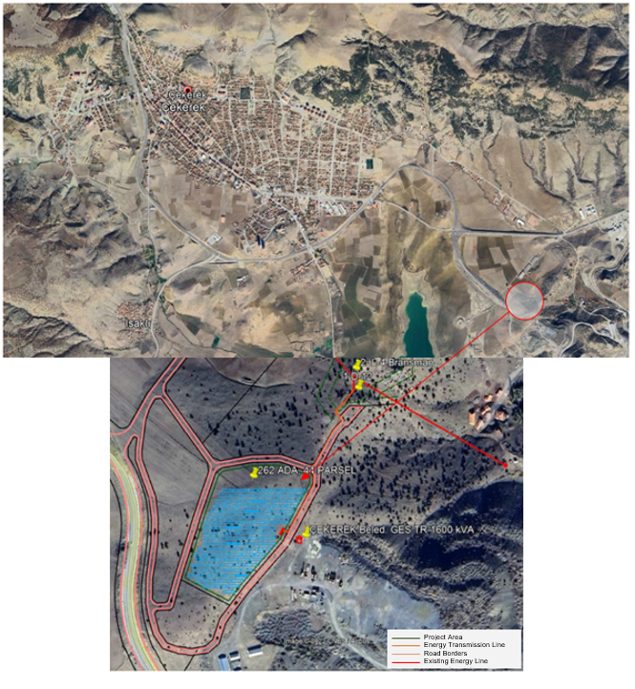
Figure 1. Project Area
Project horizon is 30 years and it is expected that the project will generate 2.146.118 kWh electricity annualy which may reduce over time due to nature of solar panels with efficiency decrease. The generated electricity will be supplied to national grid and electricity consumption of the municipality will be netted from the generation amount and excess amount will be sold, if any.
Solar power plants with an installed power between 1 MW and 10 MW or with a project area between 2 hectares and 20 hectares are subjected to Annex-II of the EIA Regulation (Official Gazette dated 29.07.2022 and numbered 39647) Selection and Elimination Criteria. The “EIA not required” certificate has been obtained for Çekerek Municipality Solar Power Plant Project on 25.03.2020 which has been processed in accordance with the previous EIA regulation (Official Gazette No. 29186 dated November 25, 2014) and still valid as addressed in 2022 EIA Regulation. The official “EIA not Required” letter is given in Annex 2.
For the risk categorization, the project has been evaluated in accordance with World Bank Operational Policies and the E&S Project category of Çekerek Municipality SPP project has been determined as Category B Low.

ENVIRONMENTAL AND SOCIAL SCREENING
General Assessment of the Environmental and Social Processes
According to the Environmental and Social Framework Document, investments to be realized under the additional financing projects of the ESP-II require an integrated assessment of the borrower country's Environmental Impact Assessment Regulation for the ESP and the World Bank's Operational Policy on Environmental Assessment (OP 4.01).
In accordance with WBG OP 4.01 standards, relevant WBG Environmental, Health and Safety Guidelines (WBG ESGPs) will be applied to the project. Where the requirements in Turkey differ from the levels and measures presented in the ESGPs, the more stringent one will be applied in the project specifications.
The application of E&S processes to subprojects starts with a screening process:
(i) Initial E&S risk assessment by Municipalities/ Enterprises as part of sub-projects to be proposed for financing, taking into account both the national legal framework and the World Bank E&S risk categorization
(ii) Review and risk categorization of the proposed sub-projects by ILBANK's E&S team,
(iii) ILBANK PIU to consult with the World Bank's E&S team for final decision on the E&S risk categorization (Category A, B and C) of the subprojects.
Proposed subprojects will be assessed using screening forms by ILBANK PIU in consultation with the World Bank.
The results of the National EIA Process will be another source to determine the impact significance of the project as well as to determine the level of sensitivity for the Project Impact Area (e.g. presence of natural habitats, projected areas, etc.).
The environmental and social risk classification should consider relevant potential risks and impacts such as
- Type, location, sensitivity and scale of the Subproject.
- The nature and magnitude of potential E&S risks and impacts, including impacts on Natural Habitats; the nature of potential risks and impacts (e.g. whether they are irreversible, unprecedented or complex); possible mitigation measures, taking into account resettlement activities, the presence of vulnerable groups/people and the mitigation hierarchy;
- The capacity and commitment of the Sub-Borrower to manage such risks and impacts in a manner consistent with the E&S OPs, including the country's policy, legal and institutional framework; the laws, regulations, rules and procedures applicable to the investment sector; the technical and organizational capacity of the Sub-Borrower, the Sub-Borrower's past project implementation history, and the financial and human resources available for the management of the Sub-project; and
- Other risk areas that may be relevant to the delivery of E&S mitigation measures and outcomes depending on the specific Subproject and the context in which it is developed, including the nature of the proposed mitigation and technology,
Under the World Bank's Operating Policy on Environmental Assessment (O.P. 4.01), projects are classified into the following categories according to the degree of their potential impact on the environment:
- Category A, proposed project is classified as Category A if it may have significant adverse environmental impacts,
- Category B, (Low and High) A proposed project is classified as Category B if its impacts on the environment are typically site-specific, reversible in nature, less adverse than the impacts of sub-projects under Category A, and mitigation measures can be more easily designed.
Although not mentioned in the OP, in practice Category B projects can be divided into Low B and High B projects. Projects in the High B category have relatively more impacts and include more mitigation measures than projects in the Low B category, but these impacts and mitigation measures are not significant enough to be classified as Category A.
- Category C, A proposed project is classified as category C if it is likely to have minimal or no environmental impacts.
As a result of the Screening Study, E&S documents will be prepared for Category A and B in accordance with WB requirements.
A few studies are required to identify and manage the environmental and social impacts and risks of subproject activities. These studies are described under the heading of general assessments. The first of these steps is the E&S Screening study. Information on the screening studies conducted for the Project and determination of the risk category are described below.
Assessment of the National Environmental Impact Assessment (EIA) Regulation:
The results of the EIA process in Turkey are another source for determining the significance of the impacts of the Project and the sensitivity level of the Project Impact Area (e.g. presence of natural habitats, protected areas, etc.).
The National Environmental Impact Assessment (EIA) Regulation November 25, 2014/29186 is in generally aligned with the 1985 EC EIA Directive (85/337/EEC) and its 2014 amendments (2014/52/EU).
Çekerek Municipality Solar Power Plant Project is not included in the Annex 1 but included in Annex 2 lists of the "REGULATION ON ENVIRONMENTAL IMPACT ASSESSMENT" published in the Official Gazette dated 29.07.2022 and numbered 31907, since its installed capacity is higher than 1 MW. The “EIA not required” certificate has been obtained for the Project on 25.03.2020 which has been processed in accordance with the previous EIA regulation (Official Gazette No. 29186 dated November 25, 2014) and still valid as addressed in 2022 EIA Regulation. EIA not required certificate is given in Annex 2.
Purpose, Methodology, and Risk Categorization of the Environmental and Social Screening Study:
Subprojects have a preliminary screening requirement based on three categories: the nature of the project, the size of the project, and the location of the project, which are sensitive area criteria. Based on this assessment, sub-projects with potentially significant Environmental and Social (E&S) issues are identified at an early stage for detailed E&S impact assessment.
The E&S screening of the Project was conducted through face-to-face meetings and site visits, utilizing the Environmental and Social Screening Form (ESSF) and its annexes, which include relevant questions to identify the expected E&S impacts of the subproject. During face-to-face meetings and site visits,
- The Project's E&S legacy and obligations have been assessed,
- The eligibility of the sub-project in terms of PAD Criteria and Exclusion List has been reviewed,
- The relevant sub-headings of the ESMF have been checked,
- E&S issues included in the pre-feasibility report of the sub-project were reviewed,
- Potential adverse risks and impacts have been assessed, and
- The environmental and social risk category of the subproject was determined according to the WB Operating Policy on Environmental Assessment (O.P. 4.01) and the Project ESMF.
The E&S Screening is performed and E&S Screening Form is provided as Annex-3.
Potential E&S risks, positive and adverse E&S impacts of each component should be discussed, and any red flag E&S issues should be identified/provided.
The E&S Project category of the Çekerek Municipality SPP project has been determined as Category B Low according to the World Bank's Operational Policy on Environmental Assessment (O.P. 4.01) and the scope of the Project's ESMF.
Environmental risks associated with the subproject include the following assessments,
- The impacts of short-term stripping, excavation and cover, land preparation and excavation works (low scale construction activities) will be temporary and manageable,
- The contribution to air pollution and noise pollution will be temporary and manageable with the implementation of necessary mitigation measures,
- Wastewater generated by workers during the construction phase will be discharged to the existing municipal sewerage system.
- There will be no significant adverse impact on surface water and groundwater,
- There are no sensitive ecosystems and habitats close to the construction area; and
- During construction activities, waste such as oily gloves, rags, etc. and non-hazardous waste such as cable fragments, some plastics, etc. are likely to be generated. Waste will be disposed of in accordance with national regulations and World Bank Environmental, Health and Safety (EHS) Guidelines.
The social assessments associated with the sub-project include the following assessments,
- The project will not create an overflow of labor,
- The effects will not differ for men and women,
- There is no expropriation requirement, and
- There are no sensitive, protected, ecologically important or archaeological and natural protected areas within or near the project area and the project environmental impact area.

LEGAL AND INSTUTIONAL FRAMEWORK

National Legal Framwork
The main sources of the law of the Republic of Turkey are the constitution, laws, decree laws (KHK), international treaties, statutes and regulations. In Turkey, there are many laws and decrees within the framework of the duties, powers and responsibilities of institutions regarding renewable energy sources, and there are many regulations, communiqués and circulars regulating their implementation. The laws to be considered during the design, construction and operation of the project are listed below.
- 2872 numbered Environmental Law
- 2863 numbered Law on Conservation of Cultural and Natural Assets
- 2627 numbered Energy Efficiency Law
- 6446 numbered Energy Market Law
- 5346 numbered Law on Use of Renewable Energy Resources for the Purpose of Electricity Generation
- 6831 numbered Forest Law
- 167 numbered Groundwater Law
- 4857 numbered Labor Law
- 5403 numbered Soil Conservation and Land Use Law
- 6331 numbered Occupational Health and Safety Law
- 5510 numbered Social Insurances and General Health Insurance Law
- 2942 numbered Expropration Law
In addition to these laws, all regulations regarding air quality control and management environmental management permits and plans, noise control, soil quality control and management, waste management, water control management, nature protection, health and safety will be complied with. As a result, the following regulations will be considered.
- Regulation on Unlicensed Electricity Production in the Electricity Market published in the Official Gazette No. 30772
- Unlicensed Electricity Production in the Electricity Market published in the Official Gazette numbered 32120
- Regulation on Solar Energy Based Electricity Generation Plants published in the Official Gazette No. 27969

International Legal Framework
In the scope of the International Legal Framework, World Bank Policies that apply to the project is listed below.
- WB Operational Policy on Environmental Assessment Policy OP 4.01
- WB Operational Policy on Natural Habitats OP/BP 4.04
- WB Operational Policy on Physical Cultural Resources OP/BP 4.11
- WB Operational Policy on Involuntary Resettlement OP 4.12
- WB Operational Policy on International Waterways OP 7.50.
For the project, only OP 4.01 is expected to be applicable.
Apart from that the project is expected to be compliant with following policies, conventions or obejctives:
- Paris Agreement
- United Nations Sustainable Development Goals – Goal 7 and 13
- ILO Conventions

BASELINE

Project Area
Çekerek District, where the project will be carried out, is a district of Yozgat province in the Central Anatolia region. There are Tokat Province in the north of the district, Aydıncık and Sorgun Districts in the west, Sorgun and Saraykent Districts in the south and Kadışehri District in the east. The area of Çekerek District is 751 km² and its altitude is 940 meters.
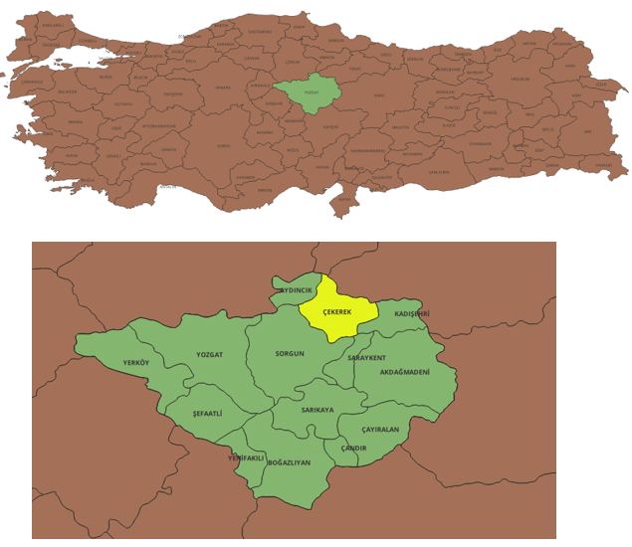
Figure 2 Location of Yozgat Province and Çekerek District
When the global radiation values of Yozgat province announced by the Solar Energy Potential Atlas (SEPA) are examined, it is seen that the highest value occurs in June with 6.43 kWh / m2 - day. With a value of 1.55 kWh / m2 - day, the month in which Yozgat province benefits from the least global radiation is December. When the sunshine duration of Yozgat province is analyzed, it is explained that the highest value is in July with 11.41 hours and the lowest value is in December with 3.33 hours, similar to solar radiation. When the energy values that can be produced with PV type area are analyzed, it is seen that the highest energy production will be with the use of monocrystalline silicon. When solar radiation, sunshine duration and the energy that can be produced with PV type area are analyzed for Çekerek district, the global radiation value is the highest in June and its value is measured as 6.32 kWh / m2 - day. July ranks first in terms of sunshine duration with 11.02 hours. The energy value that can be produced with PV type area was found to be the same as the production value of Yozgat province.
A solar potential model was developed and SEPA was created by using the data collected from EIE observation stations and DMİ data.
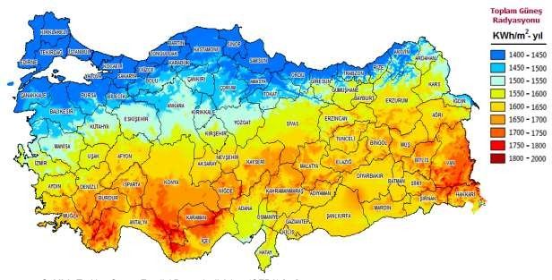

Figure 3. Turkey's Solar Energy Potential Atlas

Natural and Cultural Resources
The district of Çekerek has hosted various civilizations throughout history. There are the Genoese water cistern (Kızlar Kayası), which is very close to the town center, and the ruins of Kesipköprü, which is thought to have been used by the Hittite trade colonies, although its history is not known exactly. It is mentioned in the historical records that the castle, which is called İsaklı Castle (Çekerek Castle) in the district center and is now a protected area, was besieged by Kadı Burhanettin during the Anatolian principalities.

Project Land Use Rights
The project will be realized in the area currently designated as Renewable Energy Facility Land, registered in Çekerek District, Bahçelievler Neighbourhood, lot 44, block 262, and owned by Çekerek Municipality. Lot number of the area was 36, but then the lot is divided after urban plan applications, and lot number has changed to 44. The existing lot will be used for the newly constructed Land SPP area. Deed of the area and urban plan is given in Annex 1.
The total title deed area of the project area is 229,117.16 m², but the project will be built in a 21,716 m² area which is designated as Renewable Energy Facility Land. The generated electricity will be supplied to the grid with a connection of existing electricity pole by energy transmission line with length of 265m. Energy transmission line will be constructed on the road and no land acquisition is required since the roads belongs to the municipality. Energy transmission line can be seen from the figure below.

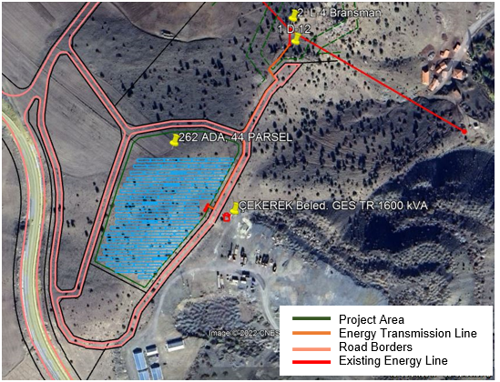
Figure 4: SPP Area and Grid Connection

Socioeconomic Situation
The population of Çekerek is 18,245 in accordance with the latest population counting which was done in 2022 published in TUİK. The population of the district has been decreasing for the last 15 years. The main source of livelihood of the district is agriculture and animal husbandry, but there are also some small and medium-sized enterprises.
The Regional Units Classification for Statistics (NUTS) is a hierarchical system created by the EU for dividing economic regions in order to collect, develop and harmonize EU regional statistics to serve socio-economic analysis of regions. According to this:
- NUTS 1: major socio-economic regions;
- NUTS 2: core regions for the implementation of regional policies;
- NUTS 3: are small regions for specific diagnoses.
As an accession country and benefiting from the NUTS classification, Türkiye has the following number of regions at different levels:
- NUTS-1: 12 regions (IBBS-1);
- NUTS-2: 26 subregions (IBBS-2) and
- NUTS-3: 81 provinces (IBBS-3).
Çekerek is a district of Yozgat and therefore it is located in TR723 region according to NUTS classification.
There are 14 provinces in the fifth level of development. Yozgat is also among these provinces. The table shows the SEGE-2017 rankings of the provinces in question and their index values.
Table 2. Fifth Tier Developed Provinces
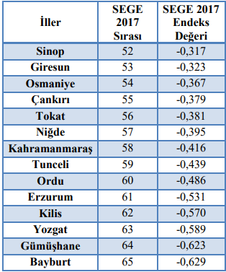
Yozgat, which is in the twelveth place of the fifth development level, is in the twelfth place with a value of 0.67 mWh in per capita household electricity consumption, which is 0.59 mWh in Turkey average. Vocational and technical high school enrollment rate (45.8 percent) and the number of pharmacies per ten thousand people (3.4) are also higher than the national average in Yozgat. variables have values below the country average. Only 2 per thousand of the number of beds with tourism investment operation and municipality certificates in Turkey are located in Yozgat.
According to the calculated social, economic and general index values of 14 districts in Yozgat, Merkez District is the most developed district of Yozgat according to economic, social and parallel general index values. According to the social index ranking, Yozgat Center ranks first, followed by Yerköy, Sorgun and Boğazlıyan districts. The least developed districts in terms of social aspects are Aydıncık and Kadışehir. In terms of economy, Sorgun follows the Center, which ranks first; Çandır is in the last place in terms of economic index ranking.
Table 3. SEDI Indices of Yozgat Districts
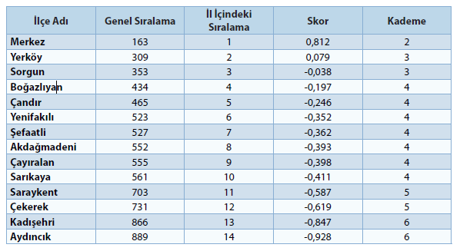
Çekerek is located in the fifth tier developed districts. The average daily income level of the districts in this level has the lowest values among all the levels. The average of Social Assistance Amount per Capita, which is one of the variables that is negatively related to socio-economic development and gives information about the poverty rate of the region, is approximately 40 percent higher than the country average at this level. At this level, the share of workplaces in high and medium high technology manufacturing industry sectors in Turkey has low values.

ENVIRONMENTAL AND SOCIAL MANAGEMENT PLAN
The Project's planned activities, outlined in the Mitigation Plan, guide the assessment of the best practices for managing potential issues. All Project tasks will align with current national laws and World Bank standards. When Turkish laws differ from World Bank policies, the stricter regulation will be followed for project implementation.
To ensure adherence to environmental and social commitments outlined in the ESMP, a comprehensive monitoring, review, and audit program specified in the Monitoring Plan will be executed during construction and operation phases. The continuous monitoring of mitigation measures and commitments outlined in the ESMP will be the joint responsibility of the contractor and the municipality, as per the Monitoring Plan.
The municipality will be responsible for ensuring that the Contractor and its subcontractors comply with applicable national/international regulations and lenders' requirements.

Mitigation Plan
Table 4. Mitigation Plan of the Project
Potential impact description | Impact | Importance of impact before mitigation | Mitigation Measures | Importance of impact after mitigation | Responsibility | Cost | Key Performance Indicators
Disturbance on flora and fauna species | Adverse | Negligible | - Prior to the land preparation phase, specific work areas will be established where activities (e.g. vegetation clearing, vegetation removal, grading and construction) and permanent structures (units and roads) will be installed. | Negligible | Contractor / Municipality | Included to Project cost | Visiual orbservations
Soil contamination | Adverse | Low | - The amount of soil that may be exposed to contamination will be minimized by ensuring that construction machinery and equipment and field personnel are used only at designated sites and routes.  - Machinery and equipment will be regularly checked for oil and fuel leaks.  - In case of any accident, leakage or spillage, necessary repair work and/or replacement of parts will be carried out immediately.  - Spill kits, absorbent pads and absorbent sands will be available at all Project construction sites at all times.  - The fuel required for construction equipment and vehicles to be used on site during the construction phase will first be procured from the nearest station; if deemed necessary, it will be stored in areas where the necessary sealing measures (including secondary containment) have been taken so that it can be stored on site  - The provisions of the Regulation on Soil Pollution Control and Point Source Contaminated Sites will be complied with.  - Wastes and wastewater that will be generated during the land preparation and construction phases of the Project will be stored and disposed of in a controlled manner in accordance with the relevant regulations and management practices described in this report. | Negligible | Contractor / Municipality | Included to Project cost | Number of incident  Incident reports
Impacts on Water Resources | Adverse | Low | - Discharge of effluents, residues or other wastes into groundwater or surface waters will be avoided. Portable toilets will be provided for workers at construction sites. Wastewater from construction sites will be collected in impermeable septic tanks and transferred to the nearest wastewater treatment plant by vacuum trucks.  - Waste water from cleaning or washing of vehicles and construction equipment will be collected in tanks and disposed of by vacuum trucks.  - Spill kits will be available at construction sites at all times. | Negligible | Contractor / Municipality | Included to Project cost | Visiual orbservations  Grievances  Sampling analysis
Decreased groundwater quality (or level) | Adverse | Low | - While determining the locations of temporary fuel or oil storage areas, the locations of water sources will be taken into consideration and spills/leaks of hazardous substances such as fuel, oil, diesel, cement, etc. will be taken under control immediately.  - In case of detection of project-induced pollution in groundwater, the Precautions Program specified in Section 3 of the Regulation on the Protection and Determination of Groundwater against Pollution will be implemented. | Negligible | Contractor / Municipality | Included to Project cost | Visiual orbservations  Grievances  Sampling analysis
Impacts of wastes on the Environment and Human Health | Adverse | Medium | - The requirements of applicable waste management regulations will be followed for the management of all waste generated as a result of Project activities.  - Waste will be separated (e.g. hazardous/non-hazardous, recyclable/non-recyclable) and stored in designated temporary storage areas.  - All kinds of waste will be transported to the licensed disposal facility through licensed waste transportation companies in accordance with the relevant legislation.  - Some hazardous or special wastes (e.g. filters and protective clothing, cloths, packaging contaminated with chemicals such as paints/solvents or oils) likely to be generated under the Project will be stored in special compartments in the Temporary Storage area. The space allocated for this purpose will be separated from non-hazardous waste in containers. Spill kits will be available in the Temporary Storage Area and necessary precautions will be taken against possible fires, such as the provision of appropriate fire extinguishing equipment.  - The floors of the storage areas will be sealed against possible contamination of soil and groundwater. In addition, appropriate drainage system will be constructed against leakages.  - Physical access to landfills will be restricted and only authorized persons will be allowed to enter landfills.  - Warning signs and boards with the name and contact number of authorized personnel will be placed in the storage areas.  - It will be ensured that waste is not dumped outside the areas allocated for this purpose and all necessary waste management trainings will be provided periodically.  - No waste shall be disposed of or incinerated on the construction site. All solid waste will be collected from generation points and transported safely to a collection point.  - Throughout the Project, all activities including collection, temporary storage, transportation and disposal of wastes will avoid any work that may threaten personnel and public health.  - Awareness should be raised by training employees on waste management practices such as zero waste.  - The principle of reduction at source will be adopted. | Low | Contractor / Municipality | Included to Project cost | Visiual orbservations  Grievances  Waste transfer records
Solid (Domestic) Waste Generation | Adverse | Low | - Waste generated under the Project will be managed according to the waste management hierarchy.  - Temporarily stored wastes will be classified according to their characteristics and labeled as hazardous or non-hazardous, waste code, amount of waste stored and storage date. Waste will be prevented from reacting with each other with the measures taken in the Temporary Storage Area.  - All solid waste will be collected from production points and transported safely to a collection point.  - Domestic solid wastes generated at the construction sites will be stored in containers and collected and disposed of daily by Çekerek Municipality.  - Packaging materials (such as sacks, pallets, parcels, plastic sheeting) of the products used at the headquarters and construction sites will be collected separately in accordance with the provisions of the "Regulation on Packaging and Packaging Waste Control".  - There will be no on-site incineration or burial of waste and/or dumping into nearby roads or water bodies.  - Employees will be trained on waste management practices. | Negligible | Contractor / Municipality | Included to Project cost | Visiual orbservations  Grievances  Waste transfer records
Hazardous Waste Generation | Adverse | Low | - Waste oils from machinery and vehicles will be stored in sealed tanks and containers placed on impermeable ground in accordance with the "Regulation on Control of Waste Oils". Tanks and containers will be equipped with apparatus to prevent overfilling and will be filled up to the specified level mark. Tanks and containers will be colored red and labeled as "waste oil".  - Used batteries and vehicle accumulators from the construction site will be disposed of in accordance with the consumer responsibilities specified in Article 13 of the "Regulation on Control of Used Batteries and Accumulators". Accordingly, used batteries will be collected separately (from municipal waste) and transferred to designated collection points (e.g. collection point of the Portable Battery Manufacturers Association (TAP)), if any in the region.  - Hazardous wastes to be temporarily stored at the site will be delivered for disposal by licensed transportation vehicles suitable for the type of waste. Information on the transactions within this scope will be recorded.  - All other hazardous substances will be disposed of in accordance with the Waste Management Regulation.  - Temporarily stored wastes will be classified according to their characteristics and labeled as hazardous or non-hazardous, waste code, amount of waste stored and storage date. Reaction of wastes with each other will be prevented.  - Hazardous wastes will be stored at the construction site away from buildings in sealed and secure containers placed on a concrete floor, established in accordance with the Waste Management Regulation. | Negligible | Contractor / Municipality | Included to Project cost | Visiual orbservations (for temproray waste storage area)  Grievances  Waste transfer records
Dust and Particulate Matter production | Adverse | Low | - The impact of dust generated during the construction phase will be reduced by adjusting the timing of works, controlling vehicle speeds and covering transportation vehicles with tarpaulins.  - Dust formation will be prevented by wetting the top of the excavation material.  - Loading/unloading will be done carefully without scattering.  - Windbreaks and barriers will be used in the work area according to the wind conditions.  - Trucks carrying excavation material will be covered, scattering of the material during transportation will be prevented, and if the material is scattered, the roads will be cleaned quickly.  - Care will be taken when loading and unloading the material.  - The route to be used for transportation of excavated material/waste will be carefully selected and care will be taken not to pass through densely populated areas  - Care will be taken to enforce speed limits for transportation vehicles. Accordingly, the speed limit will not exceed 30 km/h on poorly paved roads.  - In order to prevent the impact on air quality from affecting working and resting activities, construction activities will be carried out in specified periods and this time interval will be announced in advance to the residents who will be affected by air pollution through the communication tools of Çekerek Municipality and Contractor / Subcontractors.  - Compliance with the air emission limit values stipulated in national legislation and the World Bank General EHS Guidelines will be ensured.  - If any complaints regarding dust generation are received, dust measurements will be carried out and mitigation measures such as increased wet suppression/irrigation activities, further reduction of speed/traffic, etc. will be developed, if deemed necessary, taking into account both national and World Bank EHS Guidelines limit values. | Negligible | Contractor / Municipality | Included to Project cost | Grievances  Air quality measurements (if required)
Exhaust emissions | Adverse | Medium | - In accordance with the "Regulation on Exhaust Gas Emission Control", vehicles with traffic inspection will be subject to exhaust gas emission measurements, vehicles in need of maintenance will be serviced after routine checks, and other vehicles will be used until the maintenance is completed.  - Each vehicle to be used for transportation during the construction phase will have a "Motor Vehicles Exhaust Emission Measurement Stamp". The measurement stamp will be renewed every year by measuring the exhaust gas.  - Routine inspection and maintenance (daily and periodically) of vehicles used for transportation will be carried out. Maintenance forms will be filled in regularly.  - Fuel will be used in accordance with the standards. | Low | Contractor / Municipality | Included to Project cost | Grievances  Exhaust gas measurements
Increase in Noise Level | Adverse | Low | - Accordingly, activities to be carried out in and around settlements will be carried out during daylight hours, not in the evening and night hours.  - In order to prevent noise from affecting working and resting activities, construction activities will be carried out during designated hours and in a manner not to exceed the limit values specified in national legislation and World Bank EHS Guidelines.  - Care will be taken to select equipment with low noise level.  - Where these limit values are exceeded, sound barriers will be used around the work area. In this context, silencers or silencer parts will be used in all kinds of motor vehicles.  - Maintenance of construction machinery shall be carried out in accordance with the relevant regulations and manufacturer's recommendations.  - All construction activities will be carried out in accordance with the noise limits specified in the Environmental Noise Assessment and Management Regulation and the World Bank EHS Guidelines and additional mitigation measures will be taken by the contractor in case of a requirement arising from monitoring.  - Machinery and equipment to be used in land preparation and construction activities will not be operated at the same point/location and will be distributed homogeneously within the site.  - Machinery, equipment and vehicles with low sound power level and reduced noise will be preferred.  - If any noise complaints are received, noise measurements will be carried out and mitigation measures such as the use of noise barriers, restriction of construction activities at certain times, etc. will be developed if deemed necessary, taking into account the limit values in both national and World Bank EHS Guidelines.  - People living in the immediate vicinity will be informed about the timing of construction activities. | Low | Contractor / Municipality | Included to Project cost | Grievances  Noise level measurements (if required)
Vibration | Adverse | Low | - Sensitivity will be shown in the selection of equipment and parts in accordance with the ground vibration velocity values given in Annex-VII Table-7 of the Environmental Noise Assessment and Management Regulation.  - In case of any complaint about the selected vehicles and equipment generating vibration above the expected level, measurement studies will be carried out and necessary corrective actions will be taken to prevent the transmission of vibration from the floor and side surfaces to the ground by using elastic mattresses and steel construction if necessary. | Low | Contractor / Municipality | Included to Project cost | Grievances  Vibration level measurements (if required)
Unsuitable Working Conditions | Adverse | Low | - Workers will be provided with clear and understandable documented information on their rights under national labor law, including collective agreements, such as rights to working time, wages, overtime, compensation and benefits from the beginning of the employment relationship and when any material changes occur.  - The workplace will provide a grievance redress mechanism for workers to raise concerns. Workers will be informed about the grievance redress mechanism during recruitment and it will be made easily accessible to workers. | Low | Contractor / Municipality | Included to Project cost | Non-compliance records  Training Records  Grievance records
Workers Employed by Third Parties and Supply Chain | Adverse | Medium | - Subcontractors will be reputable and legitimate businesses and will have an appropriate Environmental and Social Management System (ESMS) to ensure that they operate in a manner consistent with working conditions requirements. | Low | Contractor / Municipality | Included to Project cost | Sub-contractor contracts  Grievance records
Child labor, forced and informal labor | Adverse | Medium | - Informal labor, child labor and forced labor shall be prevented. Where construction activities are subcontracted, the Contractor shall establish procedures to manage and monitor the performance of subcontractors in relation to the requirements to prevent child labor, informal labor and forced labor. The Contractor shall require such subcontractors to include requirements and remedies for non-compliance in their contract agreements. | Low | Contractor / Municipality | Included to Project cost | Social insurance records  Grievance records
Temporary worker flows Risk of social conflict Impacts on community dynamics | Adverse | Medium | - During the contract period, Çekerek Municipality will ask the contractor to make workforce planning and prepare a Workforce Management Plan. Municipality will evaluate this plan and submit it to ILBANK for approval.  - The Municipality and the Contractor will ensure that all employees are trained on code of conduct and communication with the public as orientation training to avoid any potential conflict in the future. | Low | Contractor / Municipality | Included to Project cost | Grievance records
Inadequate worker health and safety conditions | Adverse | Medium | - The Contractor formally agrees that all works will be carried out in a safe and disciplined manner and designed to minimize risks to neighboring residents and the environment.  - A leaflet will be prepared by the Contractor and will include a sketch of the site, emergency contact details, start date and targeted end date. The leaflet will be distributed to all buildings in the vicinity of the construction sites.  - Occupational health and safety training for employees will be carried out in accordance with the following points:  - Trainings will be carried out in accordance with the Regulation on Procedures and Principles Regarding Occupational Health and Safety Trainings of Employees,  - The Contractor shall inform its personnel about occupational health and safety issues in general and specifically about the Health and Safety Management Plan to be prepared by the Contractor. For this, the Contractor may use its own resources or consult with private companies or relevant departments of universities.  - A basic training will be provided at the start of the works and further training will be conducted on a monthly basis in line with the above.  - Training records will be kept and evaluation studies will be carried out after the trainings  - Operators working with chemicals will be trained on safe handling practices and emergency response procedures,  - The Contractor is obliged to ensure that the personnel of its subcontractors also receive the trainings and to take this into account in the protocols to be made with its subcontractors.  - An Emergency Preparedness and Response Plan will be prepared for a possible accident and emergency, emergency teams will be established, drills and trainings will be carried out in line with emergency scenarios.  - In accordance with international best practice and the Personal Protective Equipment Regulation, workers will be provided with appropriate Personal Protective Equipment (hard hats at all times, masks and safety glasses where necessary, safety belts and safety boots, etc.).  - An adequate OHS organizational structure as defined by the Occupational Health and Safety Regulation will be defined and the required number of full-time OHS officers will be assigned on site.  - Risk assessments will be made before starting work and staff will be trained on risks.  - The Contractor shall prepare a site specific Occupational Health and Safety (OHS) Management Plan in line with the Occupational Health and Safety Regulation and other relevant legislation and the site OHS risk assessment prepared in line with the World Bank EHS Guidelines. This plan shall include as a minimum, but not be limited to, the measures described herein. | Low | Contractor / Municipality | Included to Project cost | Number of incidents  Number of non-compliances  Training records  HSE Reports
Uncertainty of Emergency Response Methods | Adverse | Medium | - The issues related to Emergency Preparedness and Response specified in this Plan will be complied with within the framework of national and international standards.  - All accommodation areas will have adequate emergency response equipment such as first aid kits and fire fighting equipment. Appropriate emergency response equipment will be available at various locations on the construction site.  - Absorbent material, fire extinguishing equipment, etc. will be kept close to the construction site in order to intervene immediately in case of any emergency such as spillage and fire.  - Visual controls will be carried out periodically in hazardous waste storage areas and possible spills/leaks will be detected quickly.  - In case of fire, additional fire valves will be placed in narrow streets where vehicles cannot pass. | Medium | Contractor / Municipality | Included to Project cost | Number of incidents  Number of non-compliances  Training records  HSE Reports
Impacts on Local Economy, Livelihoods and Employment | Adverse | Low | - Traffic safety management measures will be implemented.  - The project will prioritize local employment as much as possible in unskilled, semi-skilled and skilled jobs. | Low | Contractor / Municipality | Included to Project cost | Grievances
Loss of Land and Structures | Adverse | Low | - In the event of unforeseen damage to neighboring land, assets, crops and structures during the construction works, the Contractor shall compensate the damages.  - Affected people will be provided assistance by the project to enable them to improve their living standards and will be fully compensated for land loss according to asset types and location.  - In any case, if a land acquisition process is triggered, full compensation will be paid to landowners in accordance with the Resettlement Policy Framework of the project and the Resettlement Action Plan to be prepared for the subproject. No landowner will be victimized. | Negligible | Contractor / Municipality | Included to Project cost | Visiual observations  Grievances
Effects on Susceptible Individuals/Groups | Adverse | Medium | - Vulnerable Groups will not be at risk of being excluded from decision-making processes for activities that will benefit them, or of receiving socially inappropriate benefits from project activities or adversely affecting their livelihoods.  - Vulnerable groups will have a voice in shaping the benefits they want to see from the Project.  - Equal participation of women in consultation and decision-making processes will be ensured.  - An adequate communication framework will be established to ensure that the voices of vulnerable groups are heard, pending issues are resolved and grievances are listened to.  - The use of access roads to the neighborhoods where training is carried out will be planned in a way that does not endanger the safety of service vehicles.  - Traffic precautions (warning signs for periods when large and dangerous loads will be transported, speed limits, settlement and school information) will be taken.  - Special crossings will be developed with additional measures for the elderly, pregnant women, young children and people with disabilities.  - Çekerek Municipality/Contractor shall inform the relevant institutions and organizations (Municipality, Electricity Distribution Company, natural gas distribution and operation company) before the start of construction in order not to affect the usage habits of those living in these areas during construction works. | Medium | Contractor / Municipality | Included to Project cost | Grievances
Greenhouse gas emissions | Adverse | Medium | - Existing construction equipment and materials will be optimally utilized to reduce GHG emissions.  - Speed restrictions on construction vehicles and equipment will be implemented to optimize fuel efficiency.  - Regular maintenance of construction vehicles and equipment will be carried out.  - Energy use of construction vehicles and equipment will be monitored.  - Project staff will be trained on energy efficiency. | Low | Contractor / Municipality | Included to Project cost | Machinery and equipment maintanance records
Communication topics with stakeholders | Adverse | Medium | - The ESMP andrelevant project documents/information will be open to project staffproject stakeholders and the public.  - The public will be informed in advance about traffic route changes, etc.  - Information materials (brochures, leaflets, etc.) will be prepared.  - Platforms/meetings will be organized for information sharing and consultation.  - There will be regular consultations with local authorities and communities regarding the construction management  - The establishment and proper functioning of a grievance redress mechanism will be ensured and information about it will be publicized.  - All stakeholders' concerns will be addressed.  - A procedure for disclosure of hygiene practices will be implemented prior to stakeholder engagement events.  - All details of victims of Gender Based Violence (GBV) and Sexual Exploitation and Sexual Exploitation and Abuse/Sexual Harassment (SES/ST) will be kept strictly confidential in the Complaint Registration Database. | Low | Contractor / Municipality | Included to Project cost | Grievances / comments / requests from stakeholders  Minutes of the meeting for the meetings with stakehodlers

Monitoring Plan
Table 5. Monitoring Plan of the Project
Potential impact description | Parameter to be monitored | Place of monitoring | Method of monitoring | Frequancy | Legal requirement for monitoring | Cost | Responsibility
Disturbance on flora and fauna species | Fauna mortality due to project activities | Project site | Visiual observation | Once in per three months | WB EHS Guidelines: Environmental - Noise  WB EHS Guidelines: Construction and Service exclusion  Environmental assessment (OP 4.01)  Natural habitat (OP 4.04)  Environmental Law  Under the title of Soil and Land Use Regulations defined in Table 2 -1  Regulations defined in Table 2- 1 under the heading of Biodiversity Conservation and Nature Protection | Included in Project Budget | Municipality and contractor
Soil contamination | Quality of Soil | Project site | Soil sampling and visiual observation | When and incident occurs or a spill is observed | WB EHS Guidelines: Community Health and Safety  WB EHS Guidelines: Contaminated Land  WB EHS Guidelines: Construction and Service exclusion  Environmental assessment (OP 4.01)  Natural habitat (OP 4.04)  Environmental Law  Under the title of Soil and Land Use Regulations defined in Table 2 -1 | Included in Project Budget | Municipality and contractor
Soil contamination | Number of spill incident | Administration office | Incident records | Monthly |  | Included in Project Budget | Municipality and contractor
Impacts on Water Resources | Water resources quality | Project site | Sampling | In case of grievance | WB EHS Guidelines: Environmental – Wastewater and recieving body water quality  WB EHS Guidelines: Construction and Service exclusion  Environmental assessment (OP 4.01)  Natural habitat (OP 4.04)  Environmental Law  Regulations defined in Table 2- 1 under Environmental Permit and License | Included in Project Budget | Municipality and contractor
Decreased groundwater quality (or level) | Quality of groundwater | Project site | Sampling | In case of grievance | WB EHS Guidelines: Environmental – Wastewater and recieving body water quality  WB EHS Guidelines: Construction and Service exclusion  Environmental assessment (OP 4.01)  Natural habitat (OP 4.04)  Environmental Law  Regulations defined in Table 2- 1 under Environmental Permit and License | Included in Project Budget | Municipality and contractor
Impacts of wastes on the Environment and Human Health | Waste transfer / disposal agreements  Waste management trainings | Administration Office | Document check | Monthly | WB EHS Guidelines:Public health and safety  WB EHS Guidelines:Environmental – Management of hazardous material  WB EHS Guidelines:Environmental – Waste Management  WB EHS Guidelines: Construction and Service exclusion  Environmental assessment (OP 4.01)  Natural habitat (OP 4.04)  Environmental Law  Regulations defined in Table 2- 1 under Environmental Permit and License | Included in Project Budget | Municipality and contractor
Impacts of wastes on the Environment and Human Health | Compliance of waste maagement | Project sites | Visiual observation | Daily |  | Included in Project Budget | Municipality and contractor
Solid (Domestic) Waste Generation | Waste transfer / disposal agreements  Waste management trainings | Administration Office | Document check | Monthly | WB EHS Guidelines:Public health and safety  WB EHS Guidelines:Environmental – Management of hazardous material  WB EHS Guidelines:Environmental – Waste Management  WB EHS Guidelines: Construction and Service exclusion  Environmental assessment (OP 4.01)  Natural habitat (OP 4.04)  Environmental Law  Regulations defined in Table 2- 1 under Environmental Permit and License | Included in Project Budget | Municipality and contractor
Solid (Domestic) Waste Generation | Compliance of waste maagement | Project sites | Visiual observation | Daily |  | Included in Project Budget | Municipality and contractor
Hazardous Waste Generation | Waste transfer / disposal agreements  Waste management trainings  Hazardous waste transfer records | Administration Office | Document check | Monthly | WB EHS Guidelines:Public health and safety  WB EHS Guidelines:Environmental – Management of hazardous material  WB EHS Guidelines:Environmental – Waste Management  WB EHS Guidelines: Construction and Service exclusion  Environmental assessment (OP 4.01)  Natural habitat (OP 4.04)  Environmental Law  Regulations defined in Table 2- 1 under Environmental Permit and License | Included in Project Budget | Municipality and contractor
Hazardous Waste Generation | Compliance of waste maagement | Project sites / temproray waste storage area | Visiual observation | Daily |  | Included in Project Budget | Municipality and contractor
Dust and Particulate Matter production | Grievances | Administration Office | Document check | Daily | WB EHS Guidelines:Public health and safety  WB EHS Guidelines:Environmental – Air emissions and ambient air quality  WB EHS Guidelines: Construction and Service exclusion  Environmental assessment (OP 4.01)  Natural habitat (OP 4.04)  Environmental Law  Regulations defined in Table 2- 1 under Environmental Permit and License | Included in Project Budget | Municipality and contractor
Dust and Particulate Matter production | Settling dust, PM10, PM2.5 | Project sites | Visiual observation and air quality sampling | In case of grievance |  | Included in Project Budget | Municipality and contractor
Exhaust emissions | Maintanance records of machniery and equipment | Administration Office | Document check | Weekly | WB EHS Guidelines:Public health and safety  WB EHS Guidelines:Environmental – Air emissions and ambient air quality  WB EHS Guidelines: Construction and Service exclusion  Environmental assessment (OP 4.01)  Natural habitat (OP 4.04)  Environmental Law  Regulations defined in Table 2- 1 under Environmental Permit and License | Included in Project Budget | Municipality and contractor
Increase in Noise Level | Grievances | Administration Office | Document check | Daily | WB EHS Guidelines:Public health and safety  WB EHS Guidelines:Environmental – noise  WB EHS Guidelines: Construction and Service exclusion  Environmental assessment (OP 4.01)  Natural habitat (OP 4.04)  Environmental Law  Regulations defined in Table 2- 1 under Environmental Permit and License | Included in Project Budget | Municipality and contractor
Increase in Noise Level | Level of noise | Project site | Noise measurement | In case of grievance |  | Included in Project Budget | Municipality and contractor
Vibration | Grievances | Administration Office | Document check | Daily | WB EHS Guidelines:Public health and safety  WB EHS Guidelines:Environmental – noise  WB EHS Guidelines: Construction and Service exclusion  Environmental assessment (OP 4.01)  Natural habitat (OP 4.04)  Environmental Law  Regulations defined in Table 2- 1 under Environmental Permit and License | Included in Project Budget | Municipality and contractor
Vibration | Level of vibration | Project site | Noise measurement | In case of grievance |  | Included in Project Budget | Municipality and contractor
Unsuitable Working Conditions | Work place hygene  Internal grievances | Administration Office | Documentation check | Weekly | WB EHS Guidelines: Occupatinoal health and safety  WB EHS Guidelines:Public health and safety  Environmental assessment (OP 4.01)  Labor Law | Included in Project Budget | Municipality and contractor
Workers Employed by Third Parties and Supply Chain | Implementation of sub-contractor’s environmental and social management system | Administration Office | Documentation check  Visiual orbservation | Before contract commencement | WB EHS Guidelines: Occupatinoal health and safety  WB EHS Guidelines:Public health and safety  Environmental assessment (OP 4.01)  Labor Law | Included in Project Budget | Municipality and contractor
Child labor, forced and informal labor | Employement records | Administration Office | Documentation check  Visiual orbservation | Before contract commencement  In case of grievance | WB EHS Guidelines: Occupatinoal health and safety  WB EHS Guidelines:Public health and safety  Environmental assessment (OP 4.01)  Labor Law | Included in Project Budget | Municipality and contractor
Temporary worker flows Risk of social conflict Impacts on community dynamics | Workforce management plan | Administration Office | Document check | Before contract commencement | WB EHS Guidelines: Occupatinoal health and safety  WB EHS Guidelines:Public health and safety  Environmental assessment (OP 4.01)  Labor Law | Included in Project Budget | Municipality and contractor
Inadequate worker health and safety conditions | Occupational health and safety management plan  Training records  Incident records | Administration Office | Document check  Training record check | Weekly | WB EHS Guidelines: Occupatinoal health and safety  WB EHS Guidelines:Public health and safety  Environmental assessment (OP 4.01)  Occupational Health and Safety Law | Included in Project Budget | Municipality and contractor
Inadequate worker health and safety conditions | PPE usage  Compliance with OHS mangament plan | Project site | Visiual observation | Daily |  | Included in Project Budget | Municipality and contractor
Uncertainty of Emergency Response Methods | Emergency response exercise | Administration Office | Document check | Weekly | WB EHS Guidelines: Occupatinoal health and safety  WB EHS Guidelines:Public health and safety  Environmental assessment (OP 4.01)  Occupational Health and Safety Law | Included in Project Budget | Municipality and contractor
Uncertainty of Emergency Response Methods | Existance of emergecy respons equipment (first aid kit, fire fighting equipment etc.) | Project site | Visiual observation | Daily |  | Included in Project Budget | Municipality and contractor
Impacts on Local Economy, Livelihoods and Employment | Number of affected entriprise | Project site and access roads | Survey studies (if needed)  Face to face meetings with owner of affected entriprises | Monthly | Environmental assessment (OP 4.01)  Involuntary Resettlement (OP 4.12) | Included in Project Budget | Municipality and contractor
Impacts on Local Economy, Livelihoods and Employment | Grievances related to decrease in income generation | Administration Office | Document check | In case of grievance |  | Included in Project Budget | Municipality and contractor
Loss of Land and Structures | Number of incident  Number of grievence | Project site and administration Office | Visiual observation and document check | In case of grievance | Environmental assessment (OP 4.01)  Involuntary Resettlement (OP 4.12) | Included in Project Budget | Municipality and contractor
Effects on Susceptible Individuals/Groups | Number of grievence and implementation of stakeholder engagement procedures | Administration Office | Document check | Daily | Environmental assessment (OP 4.01)  Involuntary Resettlement (OP 4.12) | Included in Project Budget | Municipality and contractor
Greenhouse gas emissions | Maintanance records of machniery and equipment  Energy consumption records | Administration Office | Document check | Weekly | WB EHS Guidelines:Public health and safety  Environmental assessment (OP 4.01)  Natural habitat (OP 4.04)  Environmental Law  Regulations defined in Table 2- 1 under Environmental Permit and License | Included in Project Budget | Municipality and contractor
Communication topics with stakeholders | Implementation of stakeholder engagement procedures  Grievance redress mechanism  Number and types of complaints recorded, addressed and analyzed | Administration Office | Grivance records  Participation records of meeting with stakeholders | In case of any related event | Environmental assessment (OP 4.01)  Involuntary Resettlement (OP 4.12) | Included in Project Budget | Municipality and contractor

STAKEHOLDER ENGAGEMENT

Stakeholder Analysis
This Stakeholder Analysis is based on the relevant Turkish legislation and international regulations by considering the project is exempt from EIA and classified as a Category B Project according to the WB OP 4.01. In conformity, relevant WB OPs (i.e., WB OP 4.01 and WB’s 2010 Policy on Access to Information) and EU Directives. In this regard, the relevant national and international policies considered are given below.

Previous Stakeholder Engagement Activities
For the project, a stakeholder consultation meeting was performed by ENVESU in the scope stakeholder engagement activities. The meeting was held on 01 Mayl 2024 at 14.00 o’clock in the Municipality. Minutes of the meeting is given in Annex-4.

Stakeholder Identification and Analysis
Identifying stakeholders aims to pinpoint and rank those involved in or impacted by a project, whether directly or indirectly, positively or negatively. It helps recognize individuals or groups with an interest in the project, even if they aren't directly affected by it.
Within the scope of this project, list of directly and indirectly affected stakeholders is given in table below.
Table 6. List of Stakeholders
Parties Affected by the Project | - Neighborhoods at the project site and nearby settlements and the people living there
Other Rlated Parties | - World Bank  - İlbank  - Ministry of Environment, Urbanization and Climate Change (MoEUCC)  - Ministry of Energy and Natural Resources  - Yozgat Governorship Provincial Directorate of Environment, Urbanization and Climate Change  - Ilbank Kayseri Regional Directorate  - Çekerek Municipality  - Turkish Electricity Distribution Co. (TEDAŞ)  - Çamlıbel Electricity Distribution Co.  - Contractor  - Consultant
Final Beneficiary | - Çekerek Municipality
The stakeholder identification process defines the nature of project impacts and examines the methods and frequency of engagement with stakeholders. The figure below shows a basic engagement diagram for stakeholder categories for effective engagement.

Figure 5: Engagement Diagram
As part of identifying stakeholders, it's crucial to recognize groups or individuals who might be disproportionately affected due to their vulnerable status. These could include households with disabled family members, people with chronic illnesses, elderly individuals living alone, female-headed households, households led by children, those with low or no income, and refugee households.
Although the project is located in an isolated area without nearby residential areas, ensuring minimal direct social impact on vulnerable groups like the disabled, women-led households, children, the elderly, and refugees during both construction and operation phases, there's acknowledgment that sensitive disadvantaged groups might exist within the project's scope, such as local market vendors and the general population. These groups might encompass individuals with disabilities, women leading low-income households, elderly individuals, or refugees indirectly affected by the project.

Stakeholder Engagement Program
The Stakeholder Engagement Program (SEP) serves as a control measure to ensure that essential project principles are implemented. Engagement activities will be strategically planned to involve relevant stakeholders to the maximum extent possible. This approach aims to minimize disruptions to the daily activities of local stakeholders by regulating the timing and frequency of engagement events. It's crucial to document findings and feedback from all engagement activities, share them with responsible parties, and follow through on the process. The engagement methods will respect cultural norms, provide fair access to all stakeholders, and facilitate their input. All engagement activities align with the specific schedule outlined in the project's Stakeholder Engagement Program.
Details of the Participation Methods to be used is as follows:
- Public/Community Meetings: Public meetings will be held and aim to inform stakeholders on project progress, environmental impacts and mitigation measures, potential constraints related to access to services and feedback from stakeholders.
- Media Communication: Media channels will be used as much as possible to disseminate information, as local media usage rates are high among people of different ages and backgrounds in project-affected communities.
- Communication Equipment: Written information will be disclosed through various means of communication and various materials, including brochures, flyers, posters, etc.
- Project Site Visits for Media and Local Representatives: If necessary, site visits or roadshows will be organized for selected stakeholders from media outlets or local authorities at appropriate points during the construction phase.

Roles and Responsibilities
Çekerek Municipality and Contractor will implement the SEP activities during the construction and operation phases of the Project. The planned organizational structure of the Team is presented in table below
Table 7. Responsibilities of Key Actors/Stakeholders in SEP Implementation
Actor/Stakeholders | Responsibilities
Çekerek Municipality | SEP Management  Stakeholder engagement activities;  Establishment of Grievance Redress Mechanism  Management or resolution of Grievances resolution;  Consultation on specific SEP activities;
ILBANK | Monitoring and supervising the process of SEP implementation;  Reporting the progress of SEP implementation to WB on regular periods
Contractor/Subcontractor(s) | Taking part of in SEP activities;  Reporting of issues to Alaplı Municipality related to stakeholder engagement;  Grievance management and resolution;  Resolution of grievances issues resulting from construction activities with collaboration and under the direction of Çekerek Municipality;  Informing Çekerek Municipality on construction activities (such as road closures and service interruptions);  Internal Reporting to Çekrek Municipality on SEP implementation
Supervision Consultant | Guide public participation and announcement requirements;  Provide necessary information to Çekerek Municipality  Review GRM and complaints to Çekerek Municipality.
WB | Audit the Çekerek Municipality's compliance with the provisions set out in the SEP managed by the Municipality during the construction and operation phase via the Project Progress Reports  Visit project sites to conduct its own monitoring at certain intervals or when necessary.

Grievance Mechanism
Key elements of a Grievance Mechanism include the following:
- Clear instructions on how grievances are made and how they are handled after they are made, including a minimum time a stakeholder should expect to receive a response
- If a stakeholder is unable to submit a written complaint or is not comfortable making a complaint, alternative means to file a complaint in person with staff
In line with international requirements, a grievance mechanism has been established by Çekerek Municipality to receive, resolve and follow up on concerns and grievances of project affected communities. Çekerek Municipality will be accessible to stakeholders and will respond to all grievances (complaints, requests, opinions, suggestions) at the earliest possible time. The most important point in the grievance mechanism is to ensure that all grievances are effectively received, recorded, resolved and responded to by the Municipality within a predetermined timeline and according to their content, and that the corrective/regulatory action to be taken is acceptable to both parties. Such responses to complaints will be satisfactory to both parties and activities will be monitored and complainants will be informed about the results of corrective actions. In addition, the mechanism should be designed to be suitable for receiving and correcting anonymous complaints. After the necessary applications are made to Çekerek Municipality, they should wait for resolution.
The flow chart of grievance mechanism is given in figüre below.
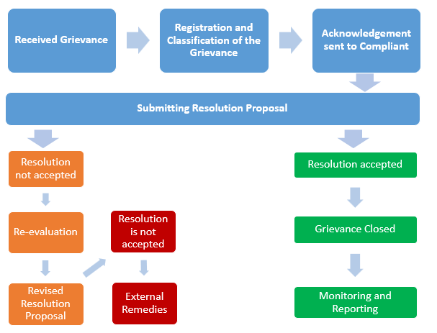
Figure 6: Grievance Mechanism Flow Chart

Grievances can be submitted from the channels below:
- Letters to be sent to address: Cumhuriyet Cd. NO: 75, 66500 Çekerek / Yozgat
- Telephones to be called no +90 (354) 468 10 12
- E-mails to be sent e mail address: info@cekerek.bel.tr
- Public meetings
- Relevant public administrations
- Staff and local communication desk of the municipality
- During site visits
- or direct visits to the municipality or Contractor’s site/administration office

Monitoring and Reporting
Stakeholder Engagement Program will be reviewed and updated periodically (per 6 months) by the contractor with help of the municipality. All grievances received will be recorded in database of the municipality and performance effectiveness of the SEP will be monitored based on number of grievance resolution.

CONCLUSION
This Environmental and Social Management Plan (ESMP) serves as a comprehensive roadmap, delineating and assessing potential environmental and social impacts anticipated during the various phases of the Project's construction and operation. It not only identifies these impacts but also proposes a suite of lendesigned mitigation measures. The aim is to proactively address and effectively mitigate any potential adverse effects that may arise. Through the holistic implementation of this ESMP, the Project's execution is poised to uphold a high standard of environmental sustainability and social responsibility. It is reassuring that, upon thorough consideration, there are no anticipated major or irreversible negative impacts that might impede the Project's overall sustainability.
To align with the stringent requirements outlined by the the Municipality is mandated to ensure transparent and accessible public disclosure of the ESMP. This dissemination is to be facilitated through both the Municipality’s official website, ensuring broad accessibility and transparency. Furthermore, recognizing the dynamic nature of environmental and social considerations, this ESMP is subject to periodic, rigorous review. Any necessary updates are meticulously incorporated, and subsequent approvals are diligently obtained. The Project Owner shoulders the responsibility for disseminating each officially approved updated version of this ESMP. This approach guarantees ongoing transparency, robustness, and accountability in the continuous evolution of the ESMP, cementing a commitment to sustainable practices.

ANNEX 1 – DEED OF THE AREA AND URBAN PLANNING

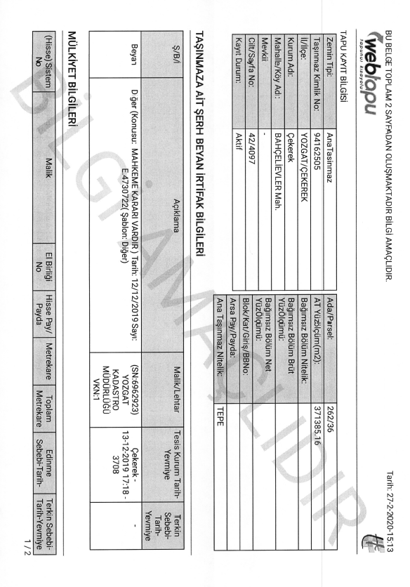
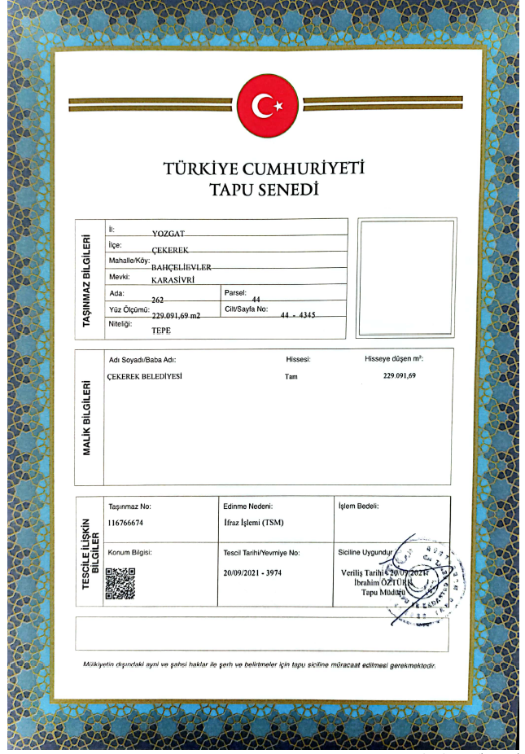
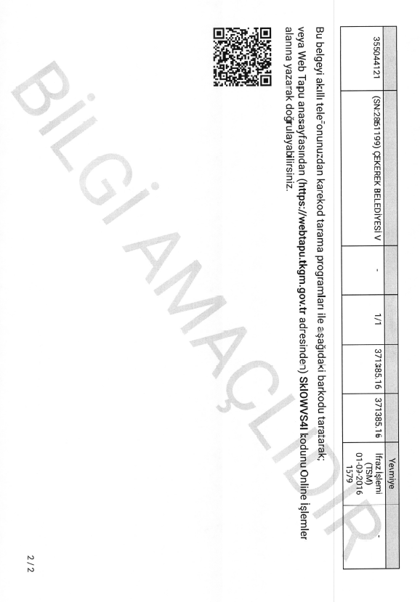
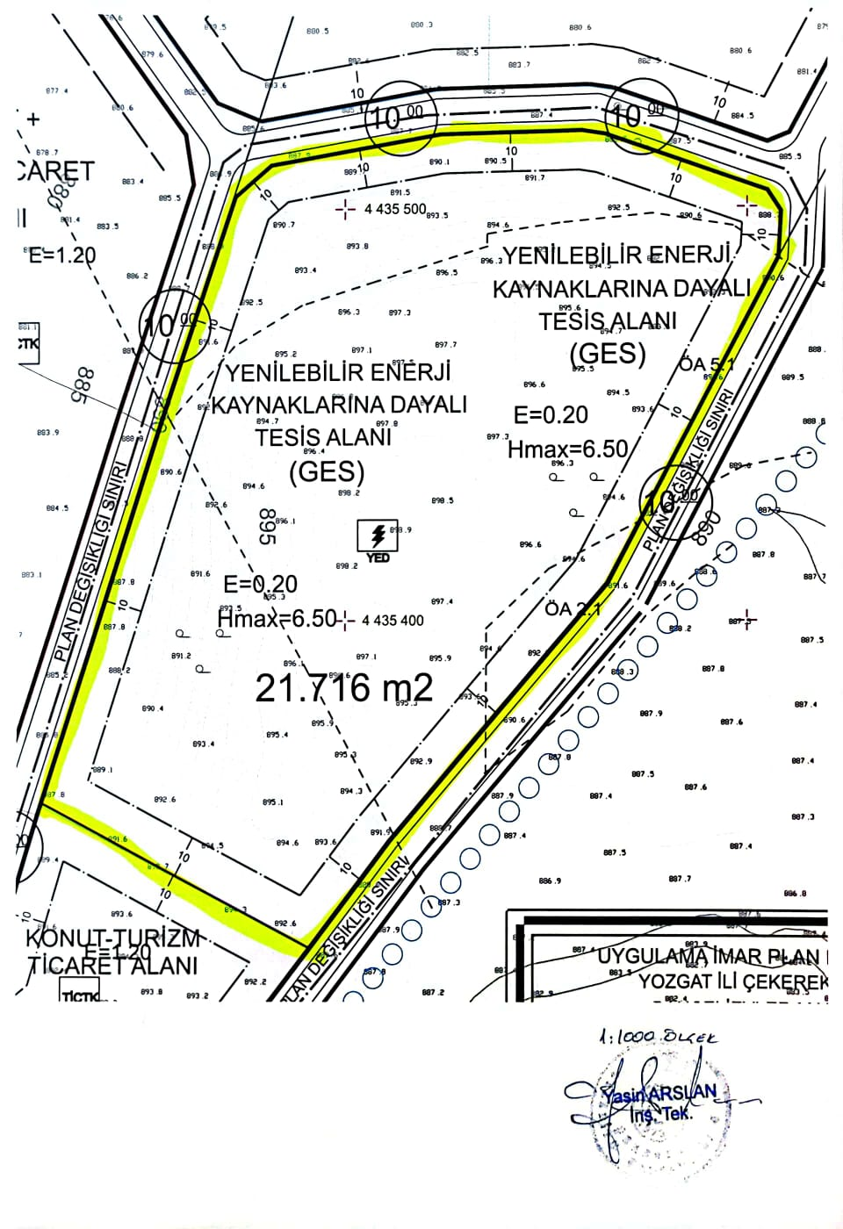

ANNEX 2 – EIA NOT REQUIRED CERTIFICATE
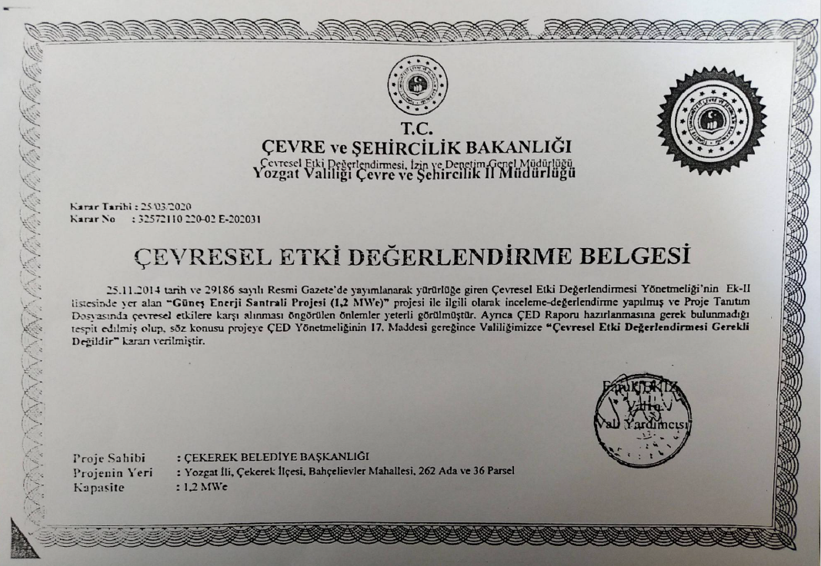

ANNEX 3 – ENVIRONMENTAL AND SOCIAL SCREENING FORM

ENVIRONMENTAL AND SOCIAL SCREENING CHECKLIST FOR SUB-PROJECTS
Sub-project Information
Sub-project title | Consultancy Services for the Preparation of Technical Feasibility Studies under the Sustainable Cities Program-II, Additional Financing (SCP-II AF) Group-1, Çekerek Municipality Solar Power Plant Project
Sub-project beneficiaries | Çekerek Municipality
Proposed date of start of work | The entire tender process of the Project will start with the advertisement in September 2023 and end with the award of the construction contract in June 2024. A 12-month construction/construction period and a 12-month Defects Liability Period are envisaged for the Project implementation. The project will be implemented in the second of 2025 and a 30-year projection has been made considering the economic life of the Solar Power Plant, accordingly the project target year is 2054.
Brief description of sub-project | This project is designed to meet some of the electricity needs of Bahçelievler Neighborhood in Çekerek District within the borders of Yozgat province by using solar energy. The area currently designated as Renewable Energy Facility Land is located on an area of 27,716 m² registered in Bahçelievler Neighborhood 262 block 44 parcel and owned by Çekerek Municipality. The existing parcel will be used for the new Land SPP area.
Site area, location | It is located in Bahçelievler Neighborhood, Çekerek District, within the borders of Yozgat province, on an area of 27,716 m² registered in 262 block 44 parcel and owned by Çekerek Municipality. The existing parcel will be used for the new Land SPP area.
Status of national EIA process of sub-project | According to the Environmental Impact Assessment Regulation, Solar Power Plant Projects are not considered within the scope of Annex-I but considered in scope of Annex-II. Therefore, the project has been exempted from EIA.

Environmental and social impacts related to the proposed sub-project – the existing situation
 | Yes | No | Details
Will the subproject adversely affect legally protected areas or internationally recognized areas of high biodiversity value? |  | X | The Project will be implemented on the existing vacant land under the Municipality. Therefore, it will not adversely affect these areas.
Will the sub-project be located in or near the environmentally sensitive or protected area (in accordance with national legislation)? |  | X | There are no environmentally sensitive protected areas in and near the Project implementation area.
Will the sub-project adversely affect critical habitats such as forest ecosystems, wetlands, marshlands, and aquatic ecosystems or natural habitats? |  | X | It will not adversely affect critical habitats or natural habitats such as forest ecosystems, wetlands, marshes and aquatic ecosystems.
Will the sub-project adversely affect endangered plant and animal species? |  | X | It will not adversely affect endangered plant and animal species.
Will the sub-project affect archaeological sites, historic monuments, and settlements? |  | X | There are no ruins and historical monuments in and near the Project area. There is no activity that will negatively and permanently affect settlements.
Is there woods or forest around the sub-project area? |  | X | There are no wooded or forest areas within the environmental impact area.
Will the sub-project adversely affect the woods and forest? |  | X
Is there any combustible and flammable subsidence material around the sub-project area? |  | X | There are no flammable and combustible debris materials around the Project area.
Is there underground facilities such as gas pipeline, electrical facilities? |  | X | There are no underground lines in the Project area.
Are there any overhead lines such as high-voltage lines in or near the sub-project area? |  | X | There are no overhead lines in and around the Project area.
Will people permanently or temporarily lose access to facilities, services, or natural resources because of the sub-project activities? |  | X | Access to natural resources is not expected to be restricted temporarily or permanently.
Does this sub-project intervention (for the Power Plant Area, Power Transmission Line or Access Road) require the acquisition of privately owned land? If so, please provide details! |  | X | No expropriation is required.
If land parcel acquisition (for Power Plant Area, Power Transmission Line or Access Road) is required, what is the actual land size and ownership status? |  | X
If new land is required (for a Power Plant Area, Power Transmission Line or Access Road) and the site is privately owned, can this land be purchased in a Buyer Willing, Seller Willing manner (excluding expropriation)? |  | X | No new land required.
Will the sub-project require the acquisition of public lands? |  | X | No public land acquisition required.
Has land been acquired for the Power Plant Area, Power Transmission Line or Access Road for the Project in the last 5 years? If yes, by what means (expropriation or voluntary purchase)? |  | X
If public land is to be acquired, are there any official/non-official users using the land for income generation? |  | X
Will there be loss of/damage to productive trees, fruit plants or crops that generate livelihood income for the households? |  | X
Is there any soil contamination observed at the sub-project area? |  | X

Impacts of sub-project (in case of rooftop solar sub-project only):
Will the sub-project affect the daily operation of the building and people? |  | X | Project activities will not affect the daily functioning of people living in the vicinity.
Is the building protected under the law for the protection of cultural heritage? |  | X
Is the building of special significance to any vulnerable group (i.e. disabled people, minorities, youth, etc.)? |  | X

Environmental and social/impacts related to sub-project construction/installation
 | Yes | No | Details
Will the sub-project involve the use of forest trees or other natural resources as building materials? |  | X | Metal material will be supplied as construction material within the scope of construction activities.
Will the sub-project emit greenhouse gases (CO₂, NOx, O₃) or ozone-depleting substances (CFC, methyl bromide, etc.)? | X |  | Greenhouse gases will be temporarily emitted during welding activities.
Will the sub-project use, produce, or discharge hazardous and toxic materials (e.g., hospital waste, industrial waste, or other?) | X |  | Waste welding iron from welding operations and materials such as gloves, overalls and cloths contaminated with them will be generated.
Will the sub-project produce or cause occupational hazards? | X |  | There will be occupational hazards as the construction machinery and equipment to be operated within the scope of construction activities will be welded and welding machines will be used.
Will the sub-project cause dust and noise pollution? | X |  | Emissions and noise from vehicles and equipment to be operated during construction activities are expected.
Will the sub-project cause water pollution? |  | X | There is no activity that will cause water pollution.
Will the sub-project cause soil pollution? |  | X | There is no activity that will cause soil pollution.
Will the sub-project result in temporary disruption to the livelihoods of any persons/households? |  | X | Not expected.
Will the sub-project cause community safety-related hazards? |  | X | There will be no public safety hazards.
Will the sub-project include significant OHS concerns? |  | X | Significant problems can be avoided by taking occupational health and safety measures during construction activities such as electrical welding, assembly and vehicle movement.
Will the sub-project cause additional traffic load? | X |  | There will be temporary additional traffic load due to the addition of logistic support vehicles to the existing traffic for the construction works to be carried out within the scope of the Project.
Will the sub-project cause any adverse impact on the closest sensitive receptors (if there is any)? |  | X
Is there a population that can be negatively affected by the sub-project? |  | X | There is no community expected to be negatively affected during the works to be carried out within the scope of Project Activities.
Other environmental or social impacts (describe the nature and severity of its impact) | All environmental and social impacts have been answered with the relevant questions above. There are no impacts other than these.
Sub-project Categorization and Need for Safeguards Instruments
Sub-project Category | ☒ Low ☐ Moderate ☐ Substantial ☐ High
Key Reasons | Short term basic construction activities that require that land leveling and simple excavation and installation of equipment. Low environmental impacts are expected to be temporary and reversible or mitigated with specific mitigation measures. There will be no irreversible impacts on the daily lives of people in the immediate vicinity. No land acquisition will be required.
Environmental and Social Instruments Required | ☒ Simplified Environmental and Social Management Plan (ESMP)  ☐ Occupational Health and Safety Management Plan (OHSMP)  ☐ Stakeholder Engagement Plan (SEP)  ☐ Community Health and Safety Management Plan (CHSMP)  ☐ Resettlement Action Plan RAP  ☐ Ex-post Social Audit (EPSA)

Status | Agency / Official | Name, Signature with Date
Prepared by | Consultant | Doğukan Arıkan
Checked and Categorized as (low, moderate, substantial, or high) by | Consultant | Mehmet Öner AKTEN
Reviewed and Approved by | Consultant | Mehmet Öner AKTEN

ANNEX 4 – STAKEHOLDER CONSULTATION MEETING

STAKEHOLDER CONSULTATION MEETING
Çekerek Municipality Solar Power Plant Projects will be financed under SCP-II-AF. The beneficiary of the project is Çekerek Municipality.
The Environmental and Social Management Plan (ESMP) has been prepared by ENVESU in accordance with Turkish environmental and social legislation, WB Safeguard Policies including Operational Policies (OPs), WBG General EHS Guidelines and Industrial Sector Guidelines and ILBANK's ESMF. In addition to these studies, following the finalization of the ESMP, a Stakeholder Consultation Meeting was held on 01 March 2024 at 14.00 o’clock. The announcement for the Consultation Meeting was published on local and national newspapers on 14.03.2024 and in the municipality’s website on 12.03.2024.
Apart from the municipality staff and the consultant, no one else from the public has participated in the meeting.
  - Content of the Meeting
The content of the presentation made by the consultant has listed below:
- Project information (i.e. project location, project capacity etc.)
- WB’s E&S policies
- Stakeholders (financer, promoter, beneficiary, public etc.)
- Potential E&S impacts of the project
- Grievance mechanism
  - Question & Answer Session
Question 1:
Mr. Yasin Arslan (Municipality Staff) has asked that “Is it possible to increase capacity of the project or another project to the scope?”
Answer 1:
Mr. Öner Akten has answered that after this moment changing the capacity or adding another project to the scope means that whole process shall begin from the beginning and promoter may not include such addition.

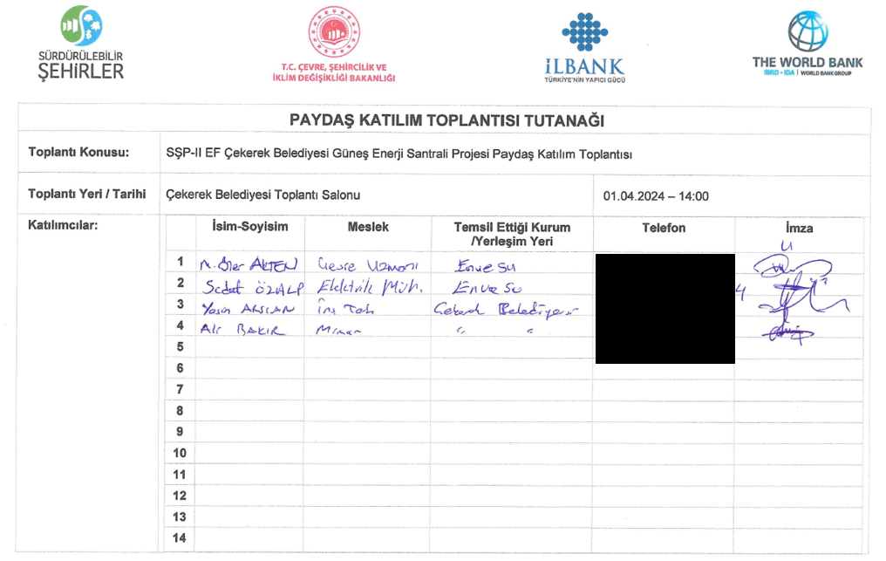
Participants List

Meeting Photos
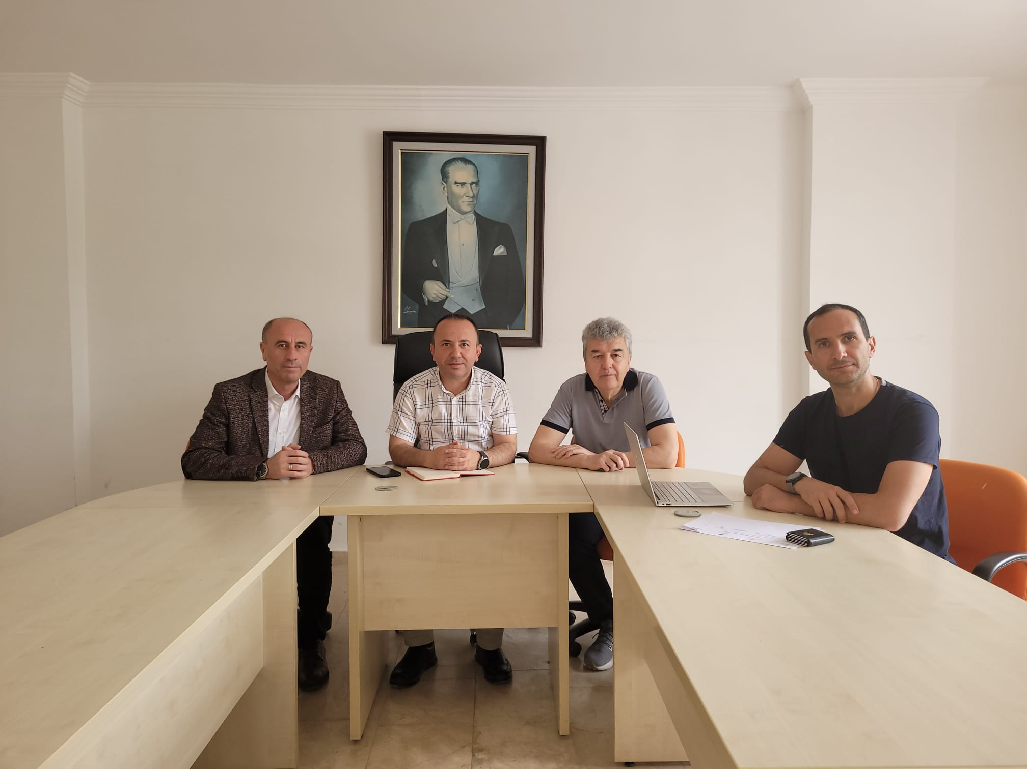

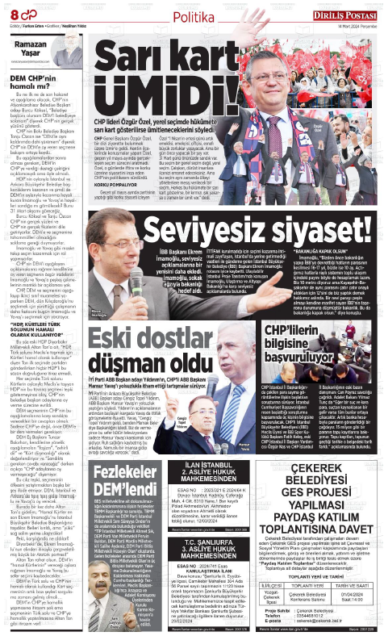
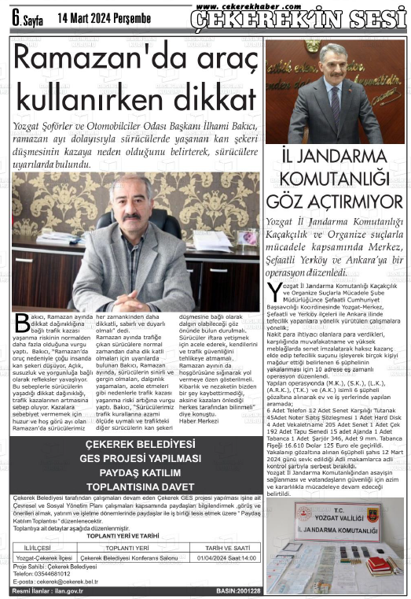
News Paper Advertisements
National Newspaper (Diriliş Postası Gazetesi)
Local Newspaper (Çekerek’in Sesi Gazetesi)

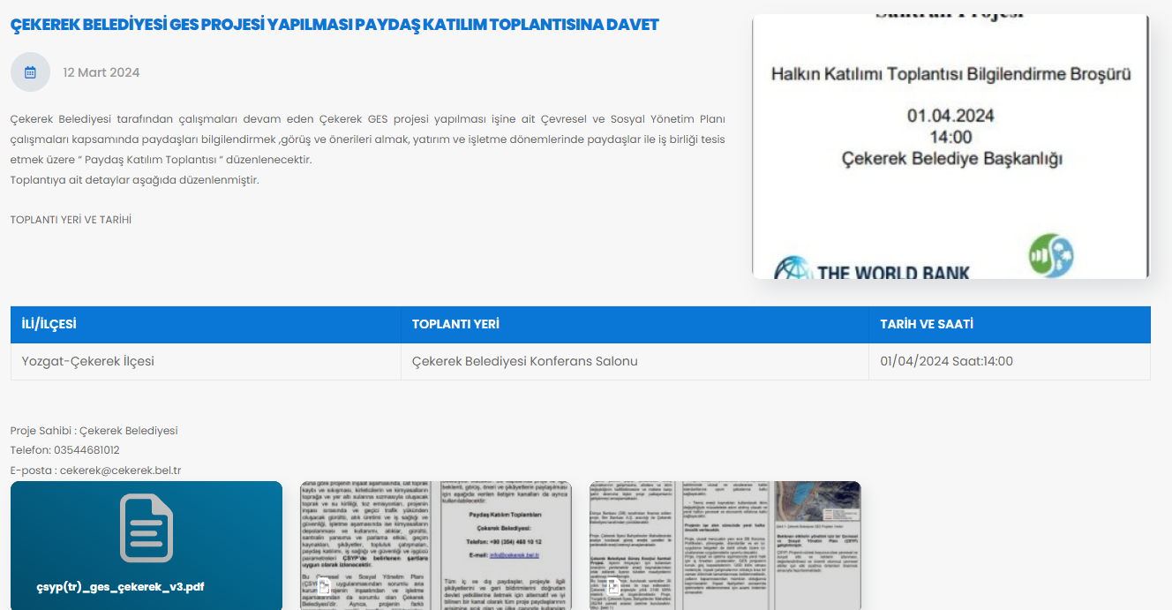
Website Advertisements
Web address: https://www.goreme.bel.tr/tr/haber/goreme-belediyesi-gunes-enerji-santrali-projesi

Stakeholder Consultation Meeting Brochure
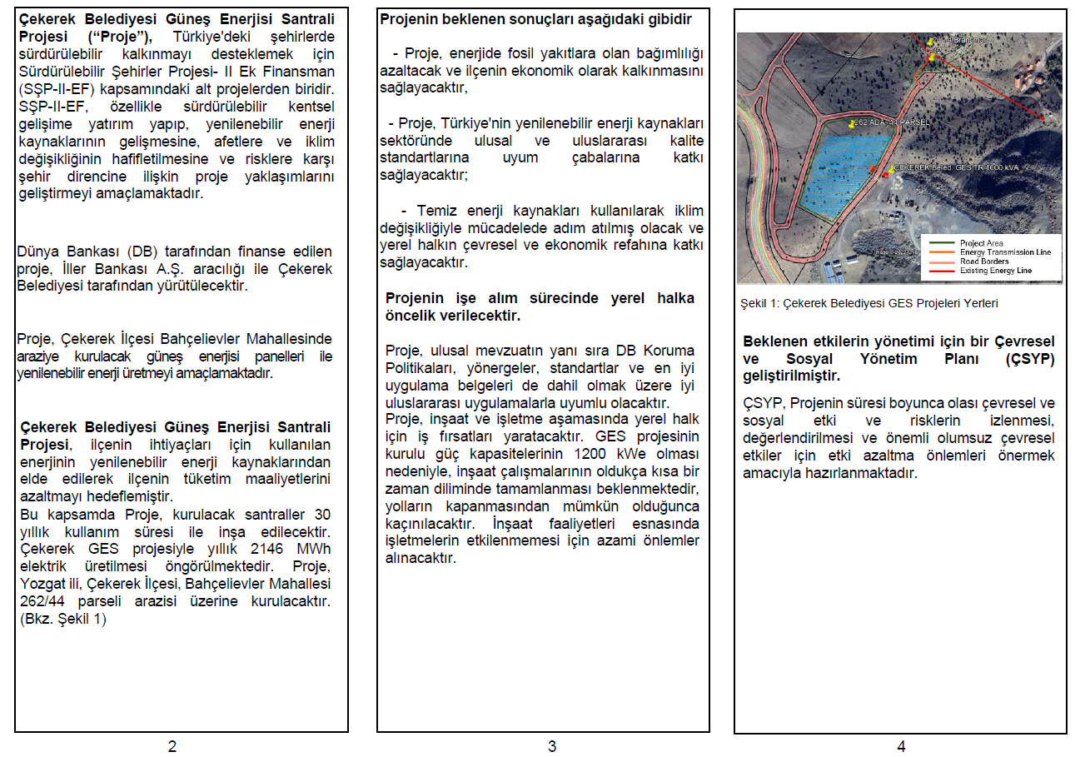
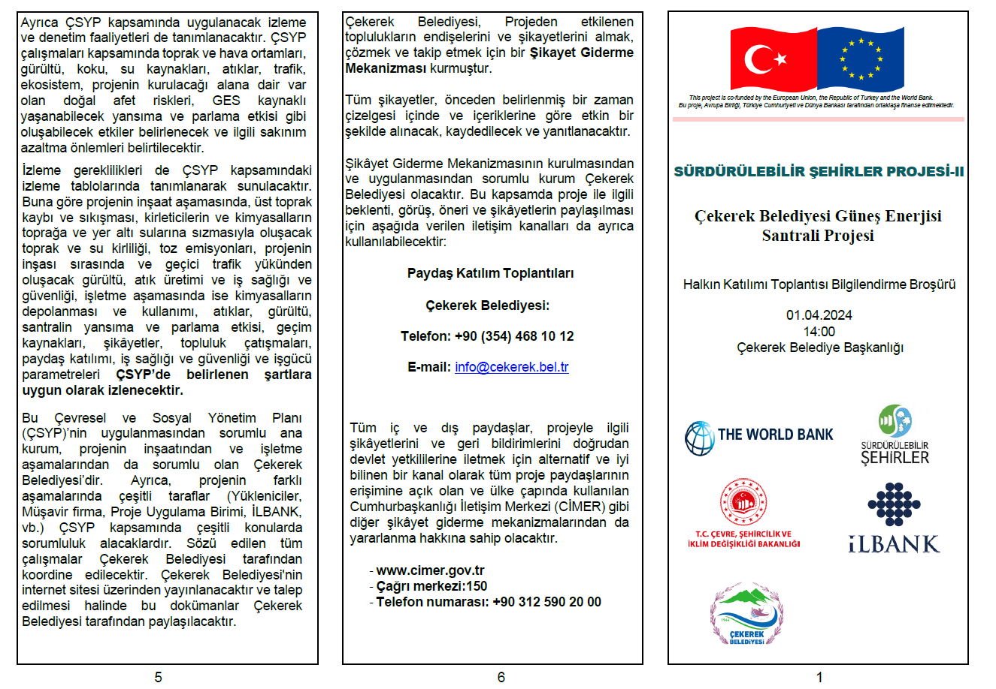

Internationally recognized areas of high biodiversity value include World Heritage Natural Sites, Biosphere Reserves, Ramsar Wetlands of International Importance, Key Biodiversity Areas, Important Bird Areas, and Alliance for Zero Extinction Sites, among others.

